***Virtual Amazon Shopping List Proposal and Analysis:***

***By: Malcolm Keniston***

1. My Amazon Virtual Shopping List is a program that will show the user the top 21 most purchased items on Amazon. Since there are a multitude of products on Amazon, I cant put all of them in the dictionary. There are two dictionary’s, one that has a “No Prime Member Price,” that accounts for shipping and one that has free shipping or “Prime Member Price.”
2. When you start the program, it will show you a selection of the products that are available using a print feature that lists all the items from the no prime member price dictionary. An example of this is

print("Your Amazon product options are:")

print(“, “.join(no_prime_member_price.keys()))

1. It will ask the user to input an item into their cart from the list above, and if it is not from the above, it will return a ("Invalid input. Please try again."). This uses a loop that only gets closed when the user types ‘done.’ After the user inputs an item, it will ask what quantity of item they want, and it has to be a number greater than 0. After you input the number, you can add more items to your list, as the loop isn’t closed.
2. After you are done inputting all the items you’d like from the list, it will print your list, and asks the question "Are you a Prime member? Type 'yes' or 'no'." Depending on your answer, you will get a different price. By using if statements and user_inputs you will be marked as a prime member. Prime Member’s get two day free shipping, and that price gets taken out in their total. If you answer no, there is a savings function that subtracts the same item from the two dictionaries and multiplies it by the quantity specified, and prints a statement that tells you how much you could have saved if you were an Amazon Prime Member. Here is an example of the code that explains that function.

savings = 0

savings += (no_prime_member_price[item] - prime_member_price[item]) * quantity

savings = round(savings, 2)

print("You would have saved $" + str(savings) + " on shipping if you were a Prime member.")

# If the user is not a Prime member, use the non-Prime member price

subtotal += no_prime_member_price[item] * quantity

1. However, for both outcomes, it will calculate the subtotal (before tax) and the total ( with an 8% tax).
2. Any errors in user input will either return a “Not Recognized,” or “Invalid Product,” and the program closes once the total and subtotal are printed.

**Pseudocode #1 for the loop and item add list:**

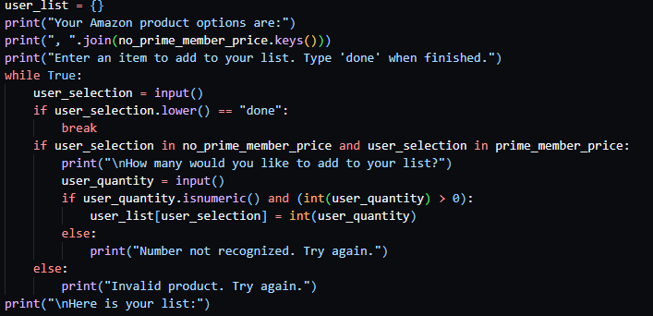

***Pseudocode #2 for checkout + prime member price calculation***

